**Applied Programming**

**Fall 2017**

**Quiz # 3**

**Registration #** ___________________________

**Q. 1: In what order should keys be inserted into an AVL tree so that we don’t have to perform any rotations?**

**Answer:**

Suppose numbers 1, 2, 3, 4, 5, 6, 7 are to be inserted into an empty AVL tree. If the numbers are inserted in the order 4, 2, 6, 1, 3, 5, 7 no rotations will need to be performed.

**Q. 2: Draw the binary search tree after the root node from the following is deleted**

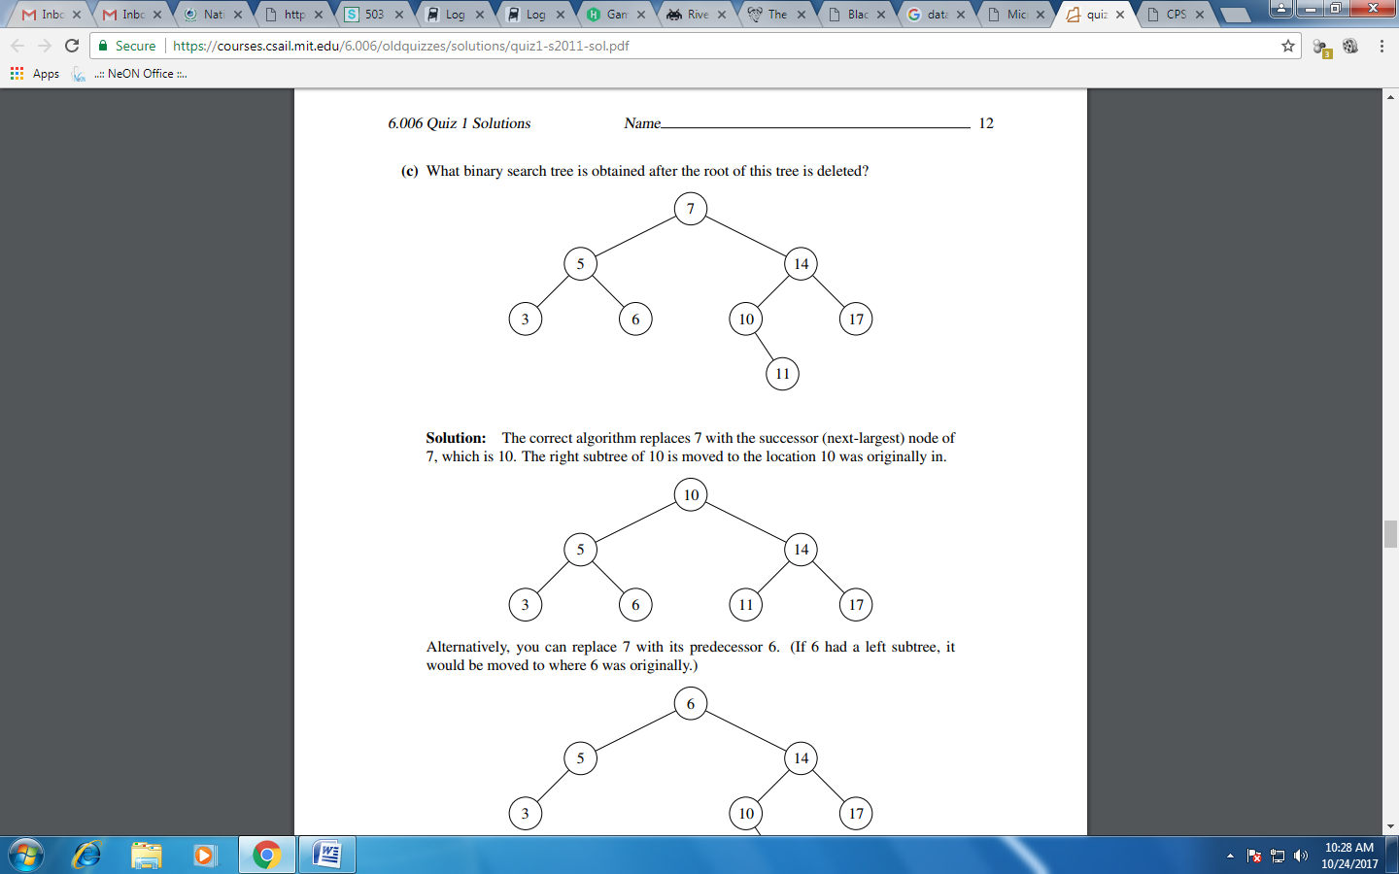

10

5 14

3 6 11 17

**Q. 3: True/False questions**

1. Inserting into an AVL tree with n nodes requires (log2n) rotations

False. Number of rotations is O(log2n) but not (log2n)

1. The height of any Binary Search Tree is O(log2n)

False. It can be up to n.

1. The key for every node in a Binary Search Tree is greater than its parent’s key

False. The key of nodes in the left subtree of a node are less than their parent’s key.